IAPPSAM - Installation Guide

- Pre-installation Procedure
  - Remove any Java and MySQL installations before installing the system.

- Open the installation CD. Start the Installation:
  - Install the Java Development Kit.
  - Install The Mysql Server.
  - Install the IAPPSAM application.
  - Post Installation Procedure
  - Backup and Recovery Procedure
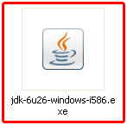
- Java Development Kit Installation:

  - Local the installer under the DVD directory. Open the Installer.

  - On the Installation Window press next.

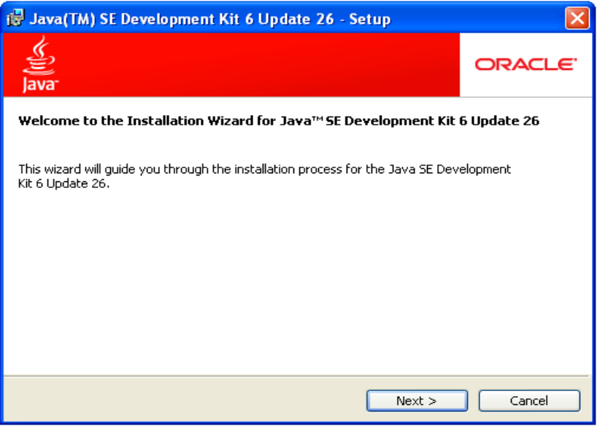

  - Do not install Public JRE.

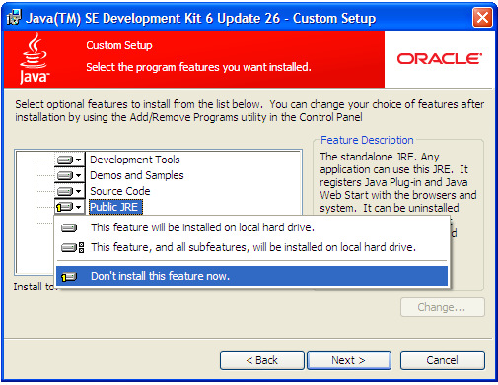

  - You may opt to change the Installation Directory. Press Next.

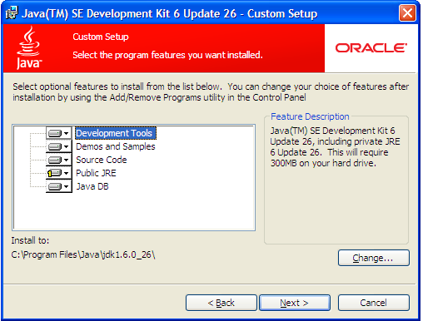

  - Product Registration is optional. Click “Finish” to exit the set-up.

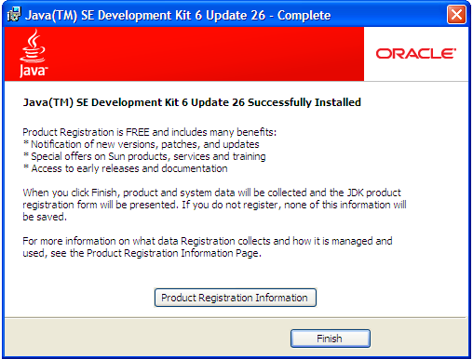

  - Go to My Computer, right click then select Properties.

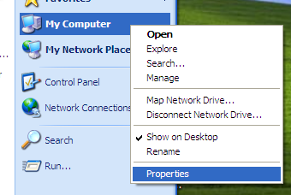

  - Select the “Advanced” Tab. Click the “Environment Variables” button.

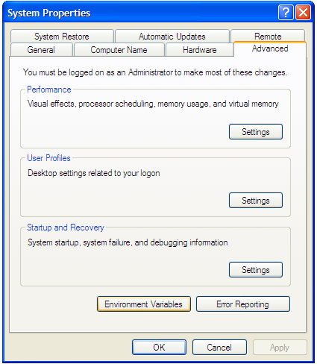

  - Select the “Path” variable and click “Edit”.

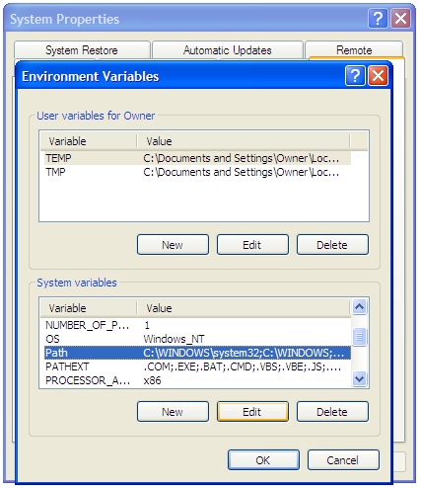

  - Append the location of the bin folder in Java installation. Click “OK” three times.

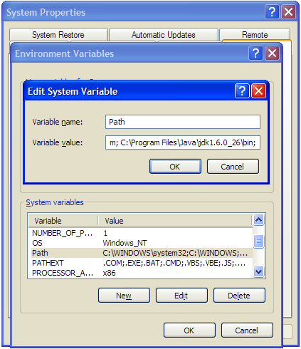

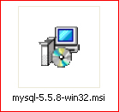
- MySQL Installation:

  - Locate the Installer in the CD directory. Open the Installer.
  - After reading the license agreement, check and proceed to the next step of the installation.

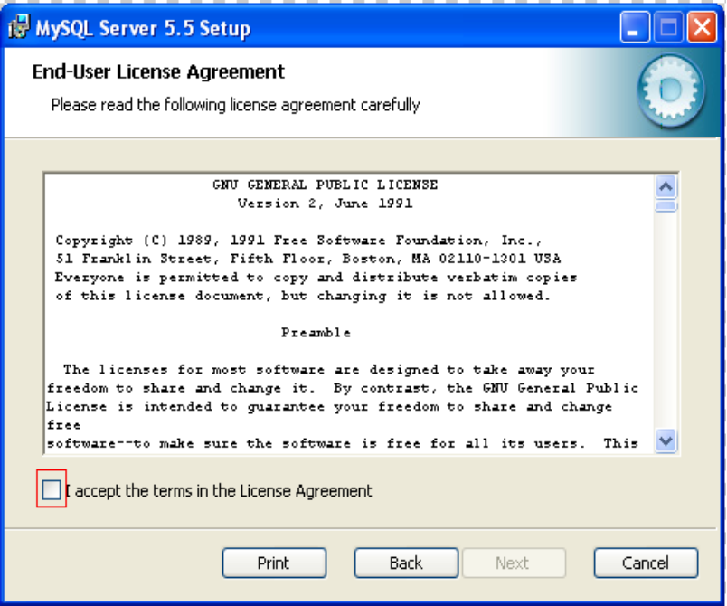

  - 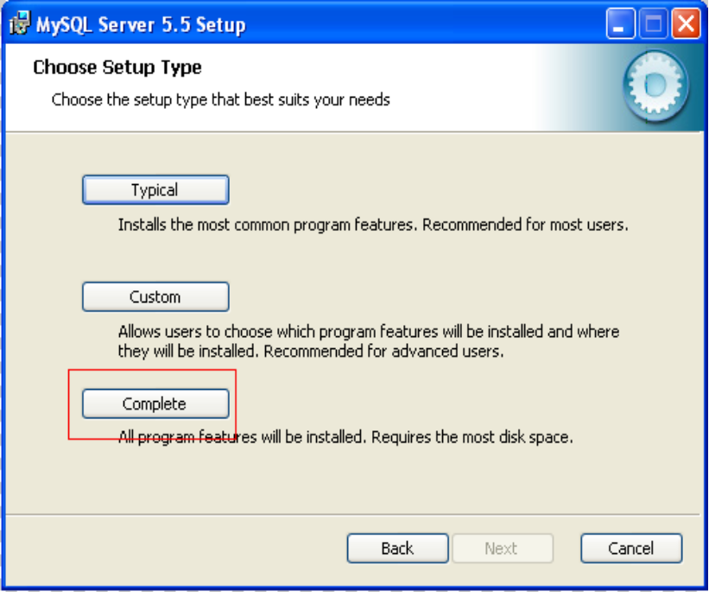In choosing the Setup Type, choose the complete installation.

  - Install the Server.
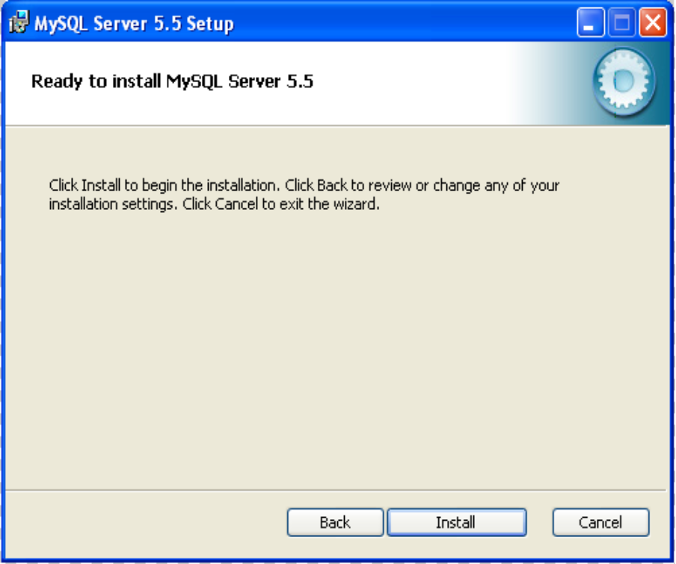

  - After installation of the SQL server, you will be directed to the MySQL Instance Configuration Wizard.

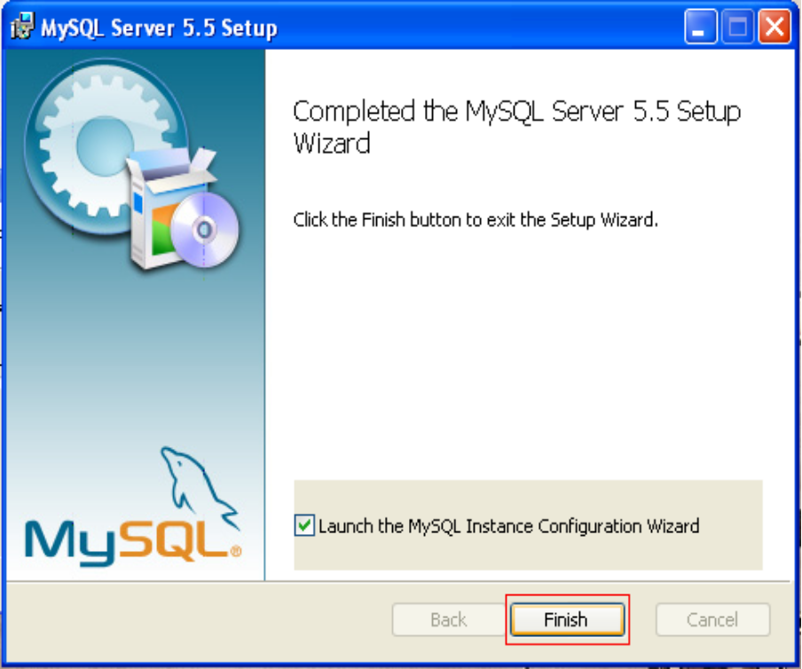

  - In the SQL Server Instance Configuration Wizard window, press next.
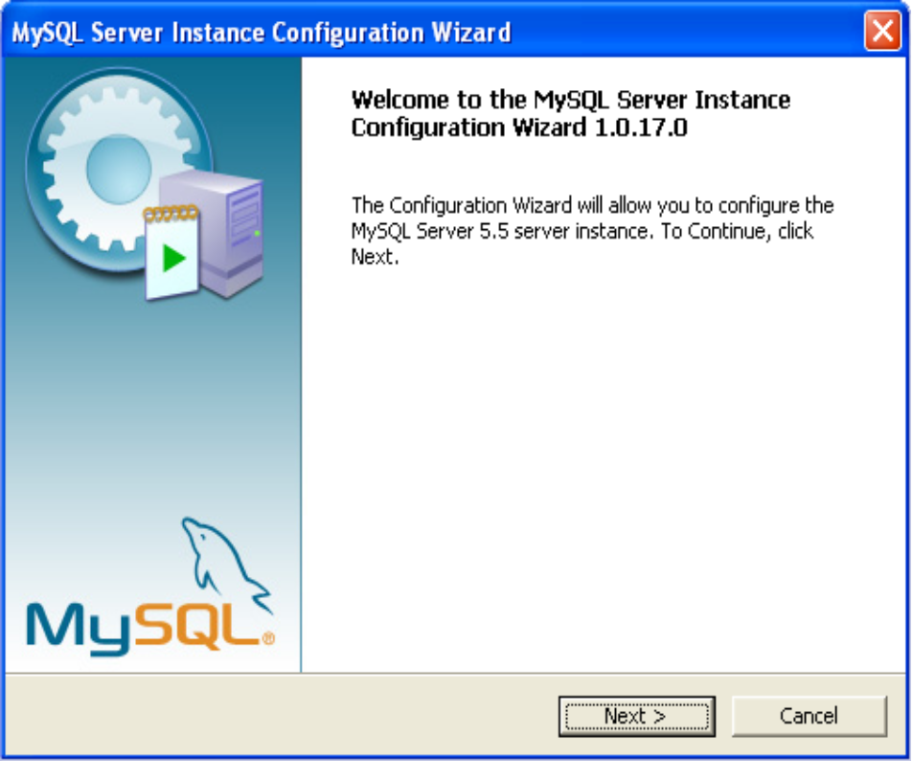

  - Choose Standard Configuration. And Next.
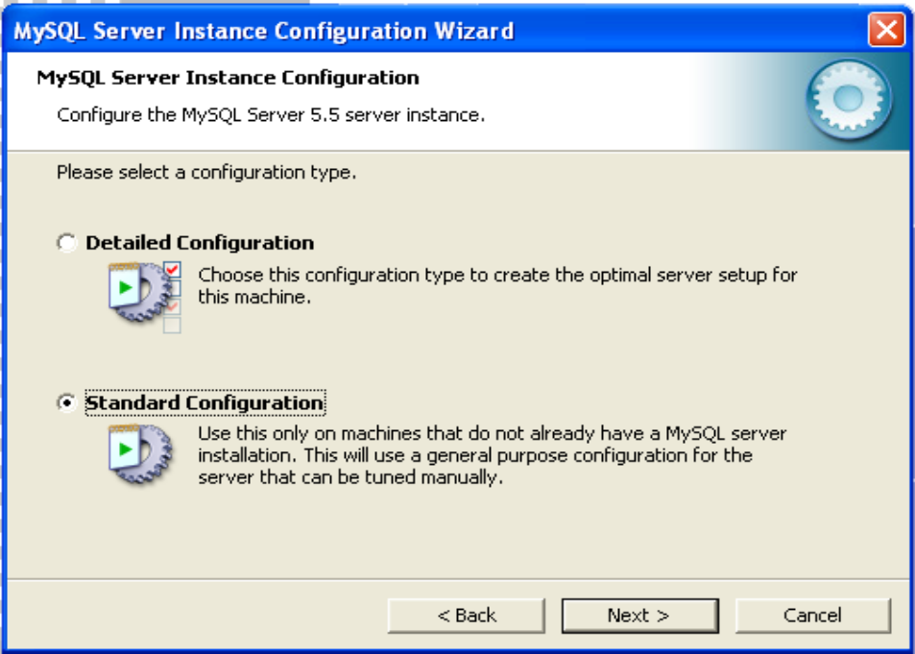

  - Add bin directory and continue on to the next page.
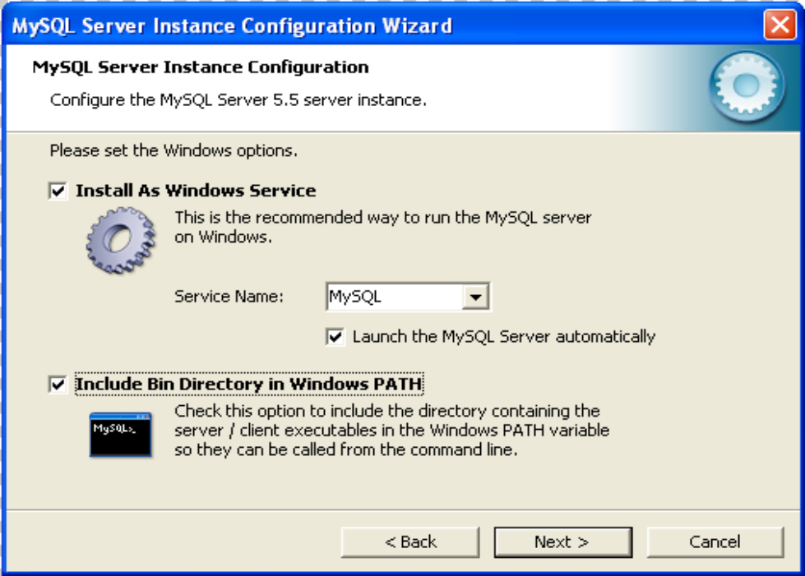

  - Select “Create An Anonymous Account”. Click “Next”.

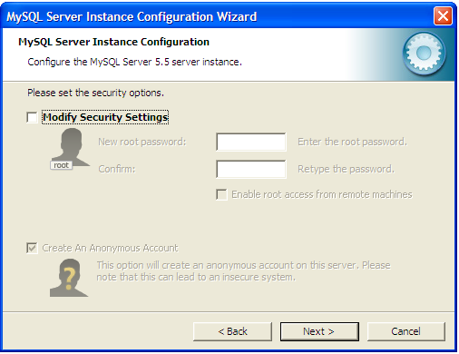

  - 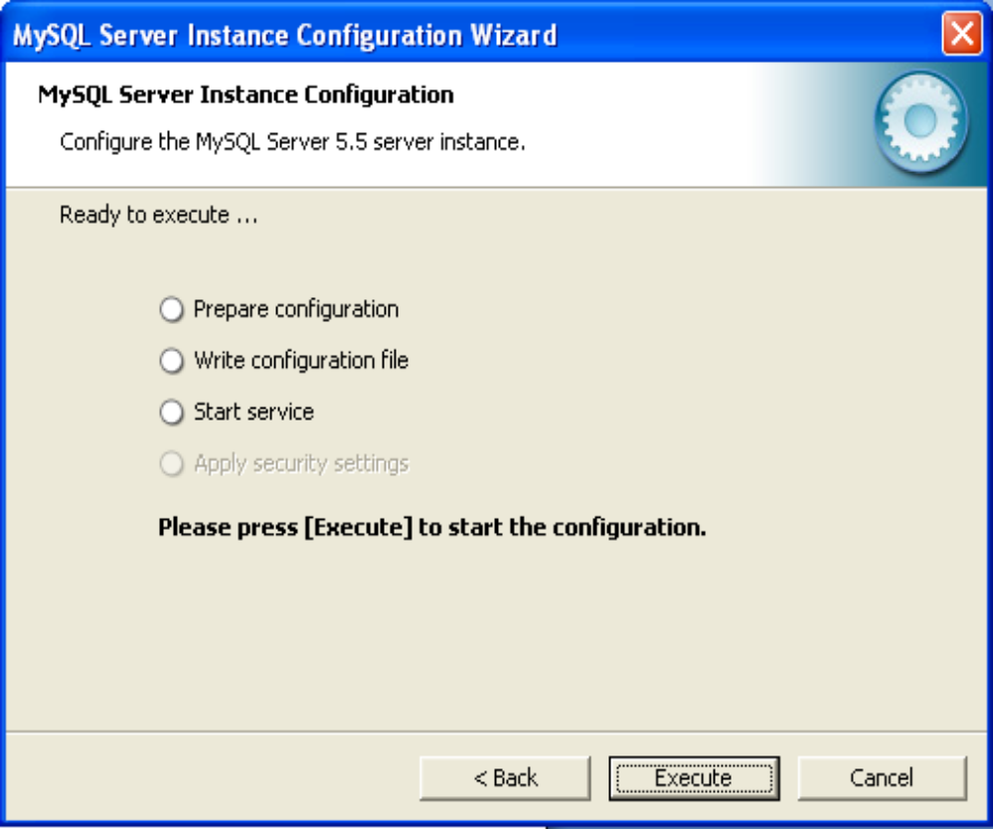Execute to start configuration.

- IAPPSAM Installation Guide:
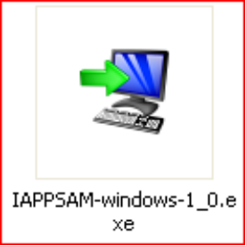
  - Locate the installer in the CD directory

  - . Open the installer.
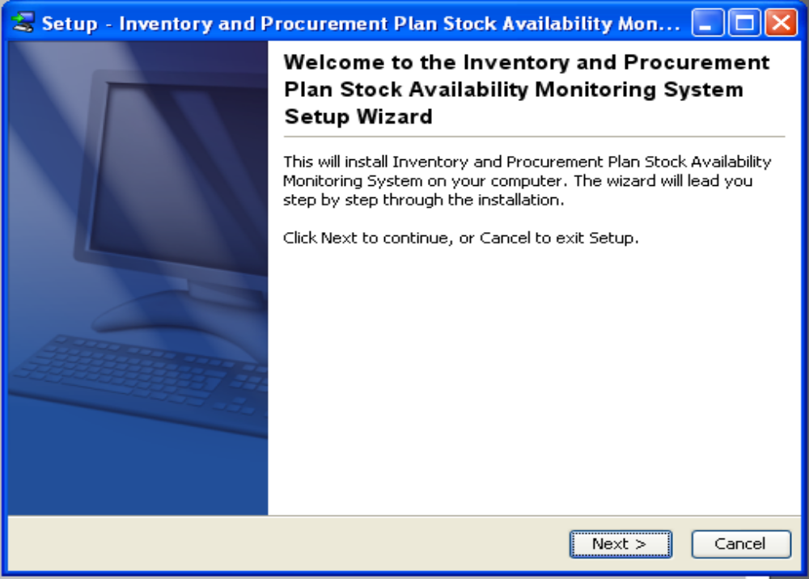

  - Choose the installation directory.
    - And press next
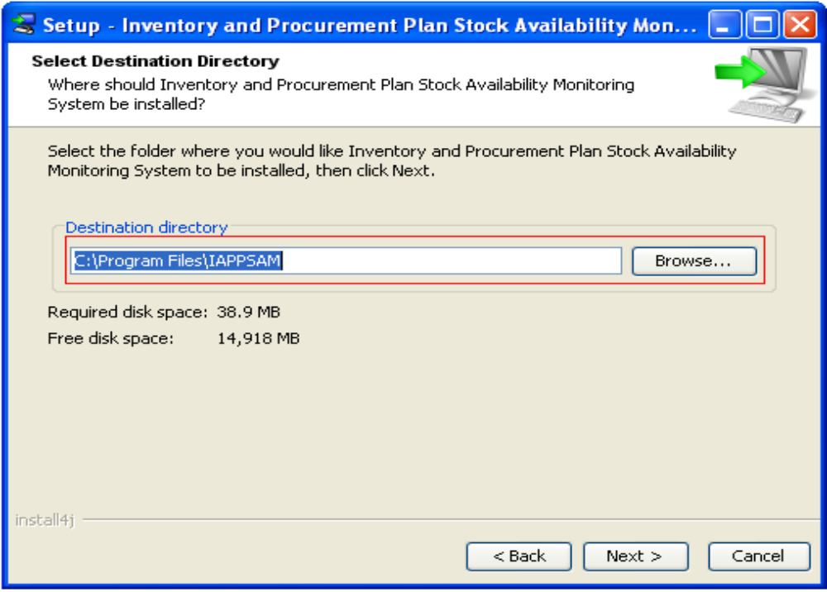

    - Define if you wish to add shortcuts to the Start Menu.
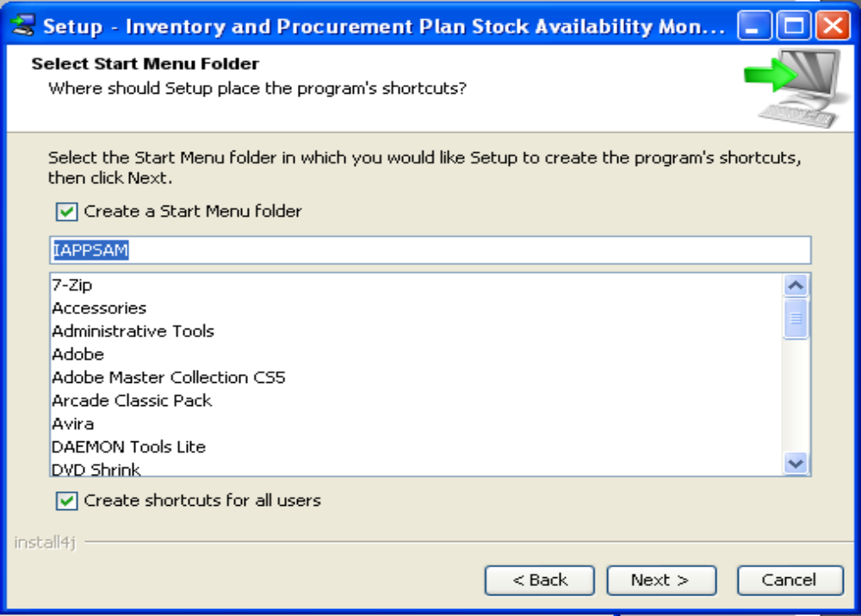

  - Finish Installation.

- Post-Installation Procedure

- Go to the location of the application: “C:\Program Files \IAPPSAM\” and open the file MySQLDumpPath.txt
- Change the contents of the file to the location of the executable mysqldump. This is usually found in: “C:\Program Files\MySQL\MySQL Server 5.5\bin\mysqldump.exe”. Change all ‘\’ characters to ‘/’. Save and close the file. IMPORTANT: Incorrect file path will cause the backup database feature to become nonfunctional.
- Run Start > Programs > IAPPSAM > Server.
- Open a Browser (preferable Google Chrome). Navigate to localhost. The default account is: Username: admin, Password: admin
- It is strongly advised that you change the password upon logging in. To do this, proceed to the “My Account” and change your password.
- Consult the “Help” page by clicking the link below the UP Logo. This will open a help page that you can use as reference.
- Click the “Post Installation Procedure” at the upper left of the screen. Follow the instructions in populating the database.

- Backup and Recovery Procedure

- After logging in, click the “Backup” button in the Database Section. Save the downloaded .sql file to desired location. This file will be used to restore/recover the database when necessary. Consult the help page for more details.
- To recover the database, run Start > Programs > IAPPSAM > Recover. Input, Username: “root”, Password: “”
- Use the downloaded .sql file to recover the database. Consult the help page for more details.

